Research Proposal: A Spatial and Machine Learning Approach to Identifying High-Risk Functional Literacy Areas in the Philippines
1. Introduction and Problem Statement
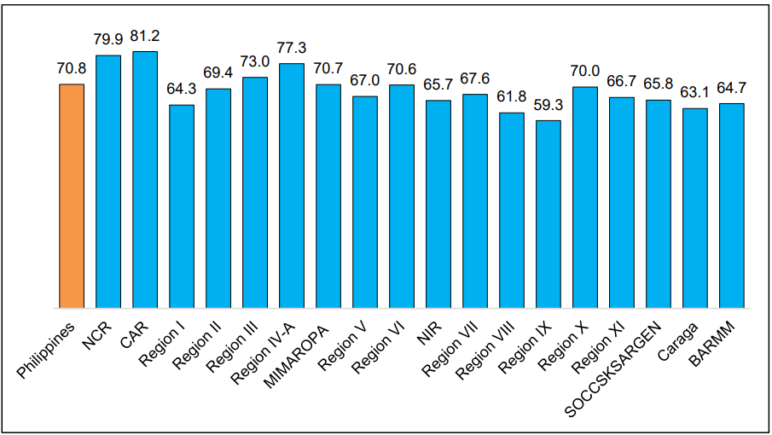
While the Philippines boasts a high national basic literacy rate of approximately 90%, functional literacy, defined as the ability to read, write, perform calculations, and comprehend information to function effectively in society, presents a starkly different reality. Recent survey data indicates a significant disparity, where only seven out of ten Filipinos exhibit functional literacy. Crucially, this functional illiteracy is not uniformly distributed across the archipelago; it constitutes a distinct spatial problem characterized by a pronounced urban-rural divide.
Source: Philippine Statistics Authority Press Release: For Every 10 Filipinos, 9 have Basic Literacy, While 7 have Functional Literacy (Final Results) 30 June 2025

Currently, resource allocation for educational and labor interventions by government agencies such as the Department of Education (DepEd) and the Department of Labor and Employment (DOLE) is often limited and applied broadly across regions. Without identifying the specific, localized drivers of illiteracy, such as internet access availability, food inflation, or regional demographic shifts, resource allocation remains inefficient. Because functional literacy impacts the broader working-age population from ages 10 to 64, addressing these disparities is critical for both educational development and labor force competency. There is a pressing need for a data-driven approach to analyze functional literacy disparities and determine precisely where, and how, intervention efforts should be focused.
2. Research Questions
To address these gaps, this study is guided by the following primary research questions:
- How unequal is the distribution of functional literacy across different provinces and Highly Urbanized Cities (HUCs) in the Philippines?
- What are the underlying socioeconomic, demographic, and spatial factors that drive this inequality?
- How can predictive modeling and spatial analysis be utilized to simulate scenarios and better target government programs for high-risk areas?
3. Review of Related Literature Functional literacy is fundamentally shaped by geographic context, as provinces differ significantly in their socioeconomic, infrastructure, and demographic compositions. Previous ecological studies utilizing data from the 2008 Functional Literacy, Education and Mass Media Survey (FLEMMS) established the presence of spatial heterogeneity in illiteracy in the Philippines. This previously conducted study demonstrated persistent disparities between urban and rural areas, even across socio-economic groups, which may suggest that aggregated published figures may mask local pockets of functional illiteracy gaps (Owada et al., 2019).
However, these specific spatial analyses were limited in scope to school-aged children. Because the FLEMMS dataset captures demographics from ages 10 to 64, this spatial inequality requires further exploration across the broader, working-age population. Furthermore, international literature examining rural-urban educational disparities, particularly in developing nations like China, demonstrates that the rural education gap varies significantly by region rather than acting as a constant. These studies argue that economic development mitigates this gap and that contextual regional factors play a substantial role in shaping educational performance. Therefore, rural inequality is not uniform; rather, it is dictated by varying social contexts, infrastructure access, and local economic conditions.
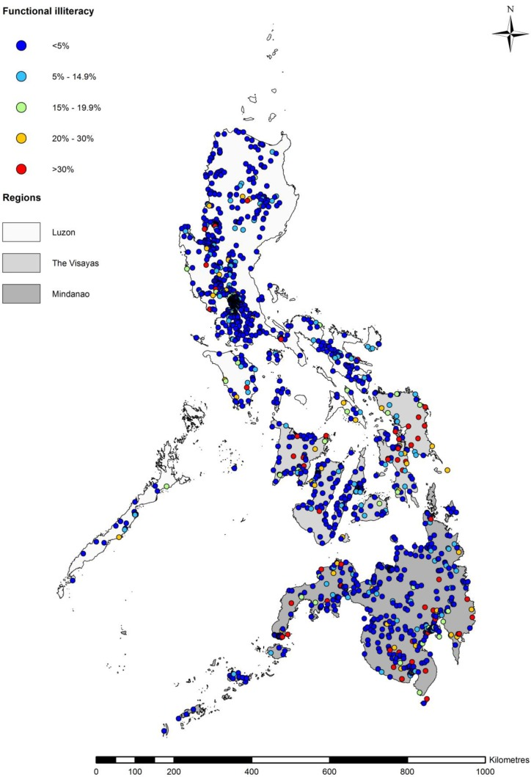

4. Data and Methodology -
In this study, High-Risk Functional Literacy Areas refer to Provinces or Highly Urbanized Cities that exhibit multiple layers of educational vulnerability. Specifically, these are areas where functional literacy rates fall below the bottom 25th percentile of the national distribution, indicating substantially weaker performance relative to the rest of the country. Beyond low rates, these areas are also identified as statistically significant “cold spots”, or Low–Low clusters, based on Local Indicators of Spatial Association (LISA) using Moran’s I, meaning they are surrounded by neighboring areas with similarly low literacy levels, reflecting geographically concentrated disadvantage rather than isolated underperformance. Furthermore, high-risk areas are those where predictive modeling suggests high sensitivity to external shocks, such as increases in poverty incidence or reductions in infrastructure access, which are projected to result in the steepest declines in literacy attainment. Together, these criteria capture not only current literacy deficits but also spatial entrenchment and structural vulnerability, providing a multidimensional framework for identifying priority areas for targeted policy intervention.
This study will employ an integrated approach utilizing spatial analysis and interpretable machine learning. The primary label for the predictive model will be provincial and HUC-level functional literacy rates sourced from the FLEMMS 2024 dataset, encompassing core literacy indicators, reading comprehension, numeracy skills, and information and communications technology (ICT) access. To formulate the predictors, this dataset will be enriched with economic indicators from the Family Income and Expenditure Survey (FIES), specifically income deciles and food expense as a ratio of total expenditures. Additional provincial-level predictors will include infrastructure metrics such as internet access and the number of available classrooms, alongside demographic features like the primary language spoken at home and regional urban-rural classifications.
The geographic dimensions of this disparity will be measured by computing literacy averages and utilizing the Gini Coefficient to evaluate the degree of inequality across regions. Furthermore, geospatial clustering techniques will be applied to identify preliminary clusters of low-performing provinces, drawing upon established spatial autocorrelation research concepts such as Local Indicators of Spatial Association (LISA) based on Moran’s I Statistic to identify statistically significant spatial vulnerabilities and spatial autocorrelation.
To explain the drivers of this inequality, a predictive model will be trained on the integrated datasets. Traditional regression models often fail to capture the complex, non-linear interactions between poverty, geography, and education. Therefore, this study will utilize Gradient Boosting Models, such as XGBoost or LightGBM, due to their high predictive power in handling these non-linear relationships. Following the interpretability frameworks outlined by Molnar (2022), the study will analyze feature interactions to measure how socioeconomic variables compound one another. Additionally, Partial Dependence Plots and Accumulated Local Effects (analyzing one variable at a time initially) will be utilized to visualize the average marginal effect of individual predictors on functional literacy outcomes.

5. Expected Outcomes and Policy Implications The ultimate goal of this research is to move beyond static measurement and provide a dynamic framework for policy simulation and early warning detection. By establishing how specific localized factors drive literacy inequality, the predictive model will allow stakeholders to simulate various targeted interventions. This includes evaluating the potential externalities of an economic slowdown, such as an increase in poverty incidence, or assessing the impact of losing educational infrastructure due to natural hazards. Conversely, the model will enable policy simulations to project the expected literacy improvements resulting from enhanced internet access, the provision of government subsidies, or improvements in high school completion rates. Ultimately, this data-driven framework will equip provincial-level LGUs and national agencies with the insights necessary to tailor specific, highly efficient policy solutions per provincial cluster.

Data

FEATURE NAME | Label/Description | DType | Location
REG | Region | Categorical | Present in all
REG2 | Region with Negros Island | Categorical | Present in all
PRV | Province | Categorical | Present in all
URBANITY | Urban / Rural | Binary | Present in all
HHID | Household ID | Categorical | Present in all
LNO | Line Number | Ordinal? | Present in all
AGE_F2 | Age of respondent | INT | Vol1 - RTF2
SEX_F2 | Sex of respondent | Binary | Vol1 - RTF2
FLITERATE | Functional Literacy: 10 to 64 yo | Binary | Vol1 - RTF2
RESP_RFACT_F2 | Form 2 Respondents Final Weights | FLOAT | Vol1 - RTF2
INTERNET | Used internet past 3 months | Binary | Vol2 - RTF3
ELECTRICITY | Electricity in the house |  | Vol2 - RTF1
 | HUC / PSGC ?????
HGC_LEVEL | Highest Educational Attainment |  | Vol2
NATT_REASON | Reasons for Not Attending School |  | Vol1
ATTEND_SCHOOL | Currently Attending School? |  | Vol1
 | Language Spoken at home?
 | INCOME |  | To be Derived from FIES
 | Number of Nearby Classrooms? |  | Not sure how to get data for this yet

References
- Anselin, L. (1995). Local Indicators of Spatial Association (LISA). Geographical Analysis, 27(2), 93-115.
- Molnar, C. (2022). Interpretable Machine Learning: A Guide for Making Black Box Models Explainable.
- Owada, K., Nielsen, M., Lau, C. L., Yakob, L., Clements, A. C. A., Leonardo, L., & Soares Magalhães, R. J. (2019). Determinants of Spatial Heterogeneity of Functional Illiteracy among School-Aged Children in the Philippines: An Ecological Study. International Journal of Environmental Research and Public Health, 16(1), 137.
- Philippine Statistics Authority. (2023). Family Income and Expenditure Survey (FIES).
- Philippine Statistics Authority. (2024). Functional Literacy, Education and Mass Media Survey (FLEMMS).
- Xiang, L., & Stillwell, J. (2023). Rural-Urban Educational Inequalities and Their Spatial Variations in China. Applied Spatial Analysis and Policy, 16(2), 873-896.

